**Project Report**

**On**

**MRF Limited Stock exchange**

**Instructor’s Name:**

**Course Full Title: Business Analytics**

**By:**

**Introduction**

The report on MRF Limited stock price gives us an adhesive analysis of stock share price in the trade market aimed at dynamic and forecasting design patterns within desired share market price. The report unveils the patterns and trends of the market share price, has showcased a consistent upward trajectory, experienced fluctuations, and a declining pattern over the years. Further, it seeks to discern the underlying trends, providing insights into the factors contributing to the observed fluctuations. Additionally, the analysis aims to unveil seasonal patterns embedded within the stock market trends, exploring the cyclic variations that could potentially highlight peaks or troughs during distinct periods of the year. By investigating these seasonal nuances, the report aims to shed light on any recurrent fluctuations, such as heightened production during specific times (e.g., holiday seasons) and lulls during others. Lastly, the report endeavors to forecast future of the stock market share price, employing a diverse array of predictive models—ranging from ARIMA and exponential smoothing to machine learning algorithms—enabling both short-term and long-term planning by projecting potential production trends.

**Objectives of the Project**

1. To identify the overall trend of MRF Limited Stock exchange over the years, and determine the trading fluctuations on the market share value and explore the reasons behind the variation in the share price.
2. Analyze the seasonal patterns of share price comparison over the past share value and determine the causes for the fluctuations happening with stock exchange price such as record price of the share and low price of the share with certain times of the calendar year.
3. To predict the future forecast of stock exchange market price depending upon the gradual fluctuation of 1 share of MRF limited traded on one day. With these share values we can predict the share prices and trade the shares and sell it over a long period of time.
4. Based on the share price market value we can estimate the future trading values and go ahead for trading the stock or sell the stock at higher prices and generate the savings according based on the market share prices
5. Basing on this we can estimate the sale patterns, by using various models, trends following while trading and follow the pattern or machine algorithm.
6. **Trend Analysis**  
   Trend analysis involves assessing the historical price movements of a stock to identify patterns and potential future directions. It allows understanding and identifying the long-term patterns or movements in the production levels over time. The analysis helps in recognizing the actual trend followed in stock pricing and has been consistently increasing, decreasing or fluctuating over a significant period. By conducting trend analysis, you can gain insights into the underlying patterns of stock pricing share values over time, enabling better decision-making and future planning.

For Visual Inspection, the time series of stock pricing was plotted against time to visualize the overall pattern. The following codes were used to analyze the trend in stock share value over a given period.

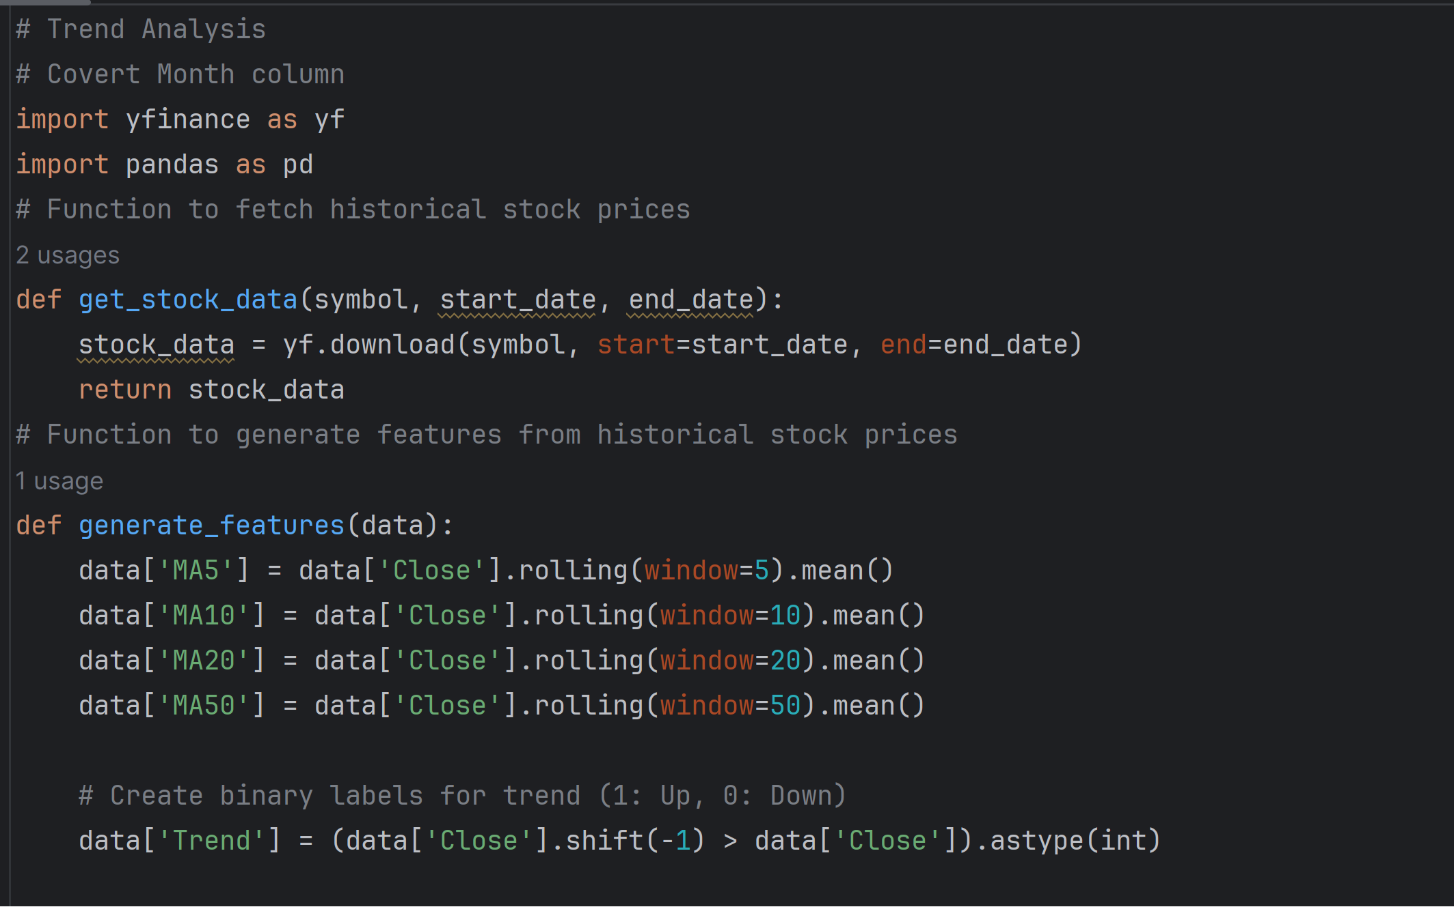

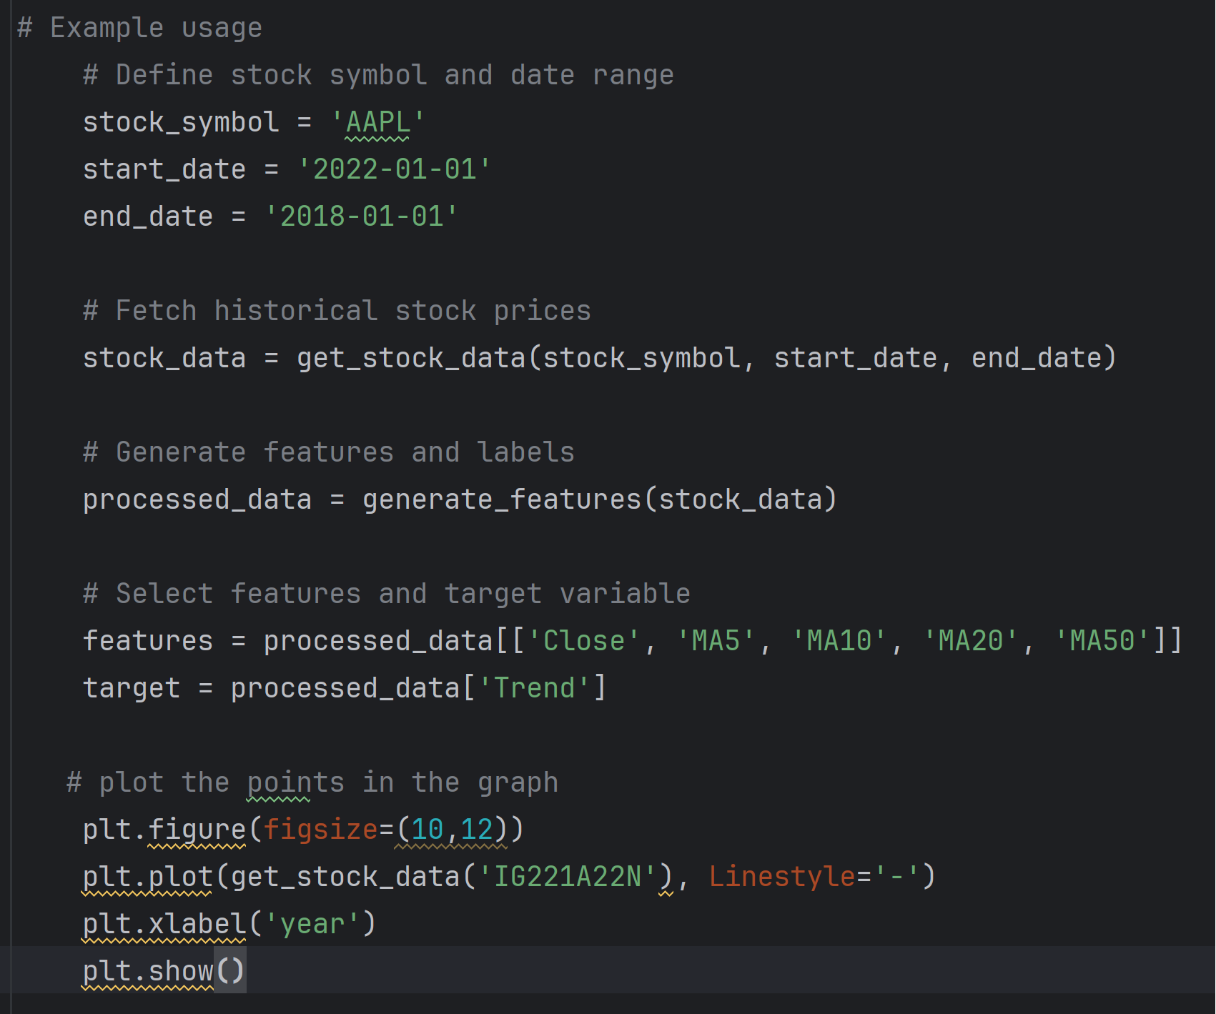

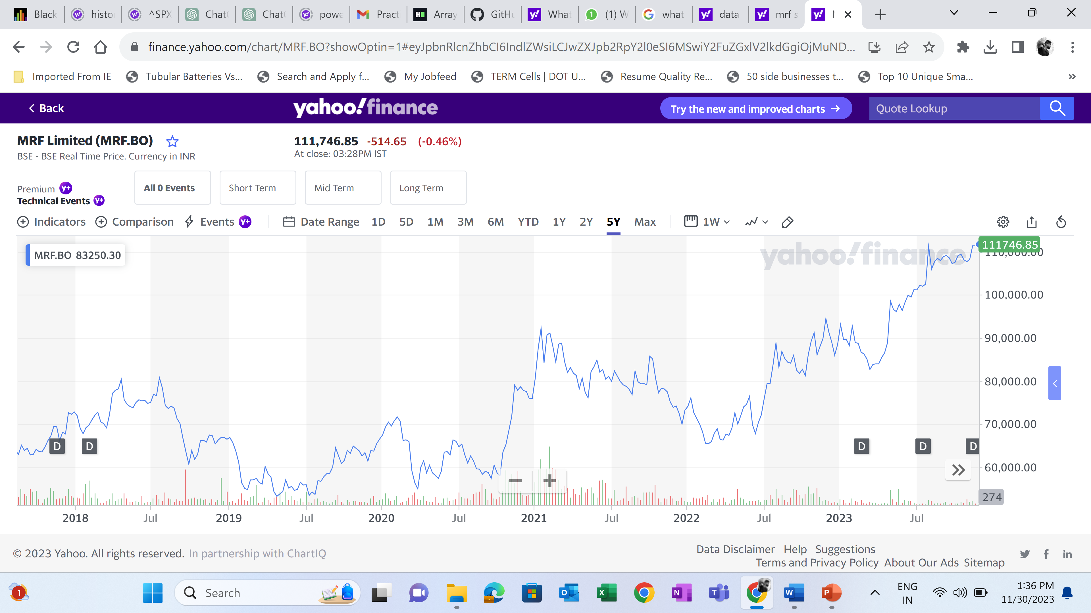

The graph clearly shows that Stock prices increase over time.

1. **Trend Identification**

A moving average in time series analysis refers to a statistical technique used to smooth out short-term fluctuations or noise in a dataset by calculating the average value of a subset of adjacent data points within a defined window or period. It involves creating a new series of values where each data point represents the average of the values within the window, moving sequentially through the dataset. This smoothing process helps reveal underlying trends or patterns by reducing random variations, making it easier to visualize and analyze the overall direction or behavior of the time series. In this project Moving Average was performed to further visualize the trend in Stocking price over time.

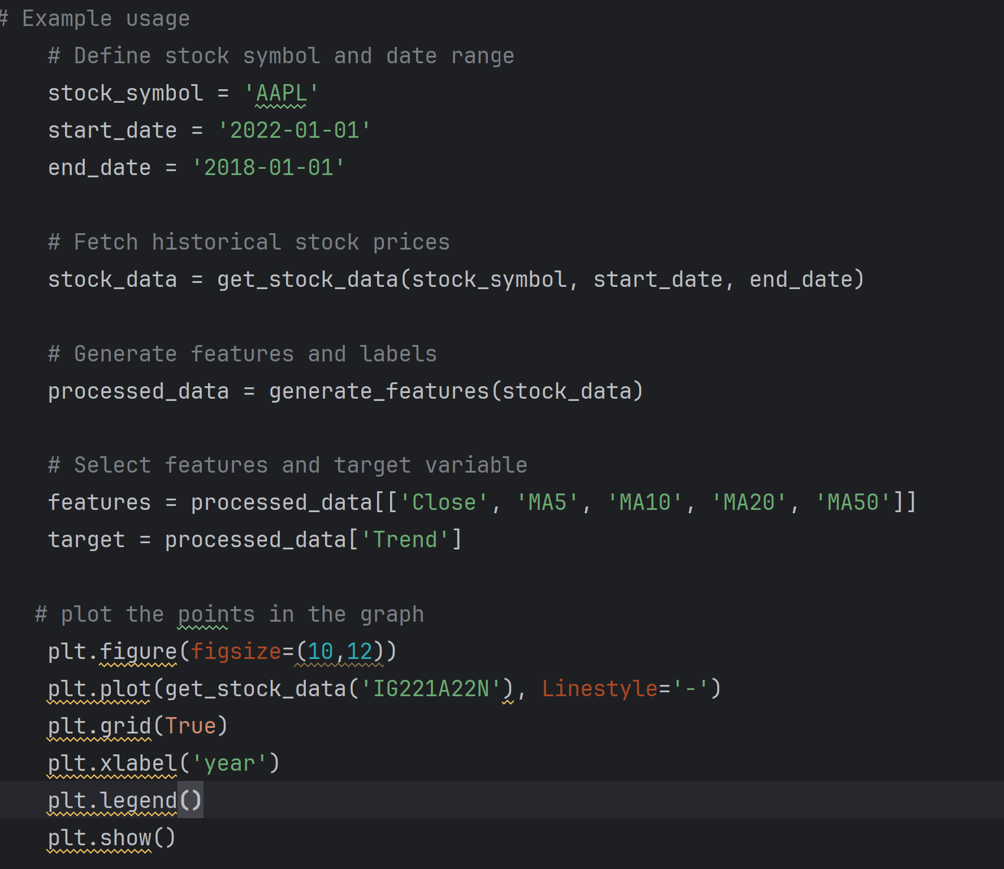

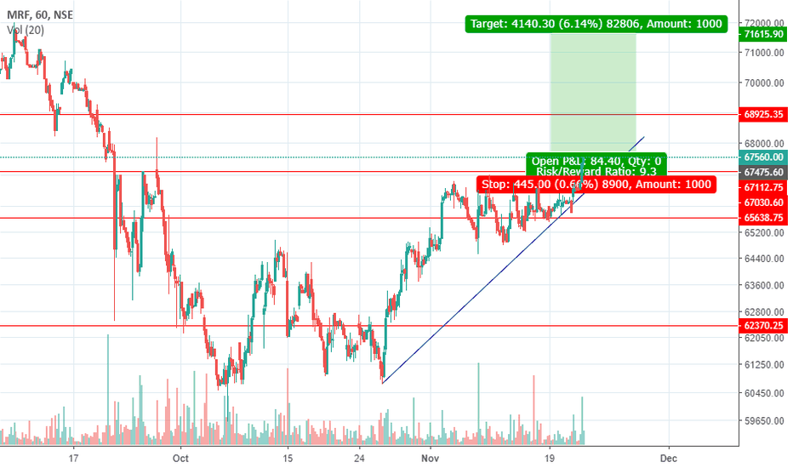

Interpreting moving averages involves understanding the smoothed trend or pattern within a time series data. This moving average provided a clearer view of the overall direction or behavior of the data by reducing short-term fluctuations and highlighting longer-term trends. The moving average represented an average value over a defined window or period, its movements indicated changes in the underlying trend. Crossing above or below the original data signaled a potential shift in direction or momentum. For instance, where the current value of the time series surpasses its moving average, suggests a potential increase or decrease in the trend.

1. **Seasonality Detection**

Detecting seasonality in the stock market involves identifying patterns or trends that occur at certain times of the year. Seasonal patterns in stock prices can be influenced by various factors, including economic cycles, holidays, and industry-specific events. Here are a few steps following while pulling out the seasonal data for detecting the changes in share value.

**Collect Historical Data:**

Obtain historical stock price data for the specific stock or market index you want to analyze. Ensure that the data covers a sufficiently long period to capture seasonal patterns.

**Time Series Analysis:**

Use time series analysis techniques to decompose the stock price data into trend, seasonality, and residual components. Popular methods include moving averages, exponential smoothing, or more advanced techniques like SARIMA (Seasonal Autoregressive Integrated Moving Average) models.

Detecting seasonality trends helps in understanding and separating these predictable cyclic behaviors from the underlying trend and random fluctuations within the time series. Analytical methods such as decomposition techniques, autocorrelation analysis, or spectral analysis are employed to isolate and quantify seasonal effects, enabling better forecasting, trend analysis, and decision-making by accounting for these recurring patterns. Identifying seasonality aids in separating these cyclic behaviors from the underlying trend and irregular components, allowing for better forecasting, trend analysis, and decision-making by accounting for these predictable variations.

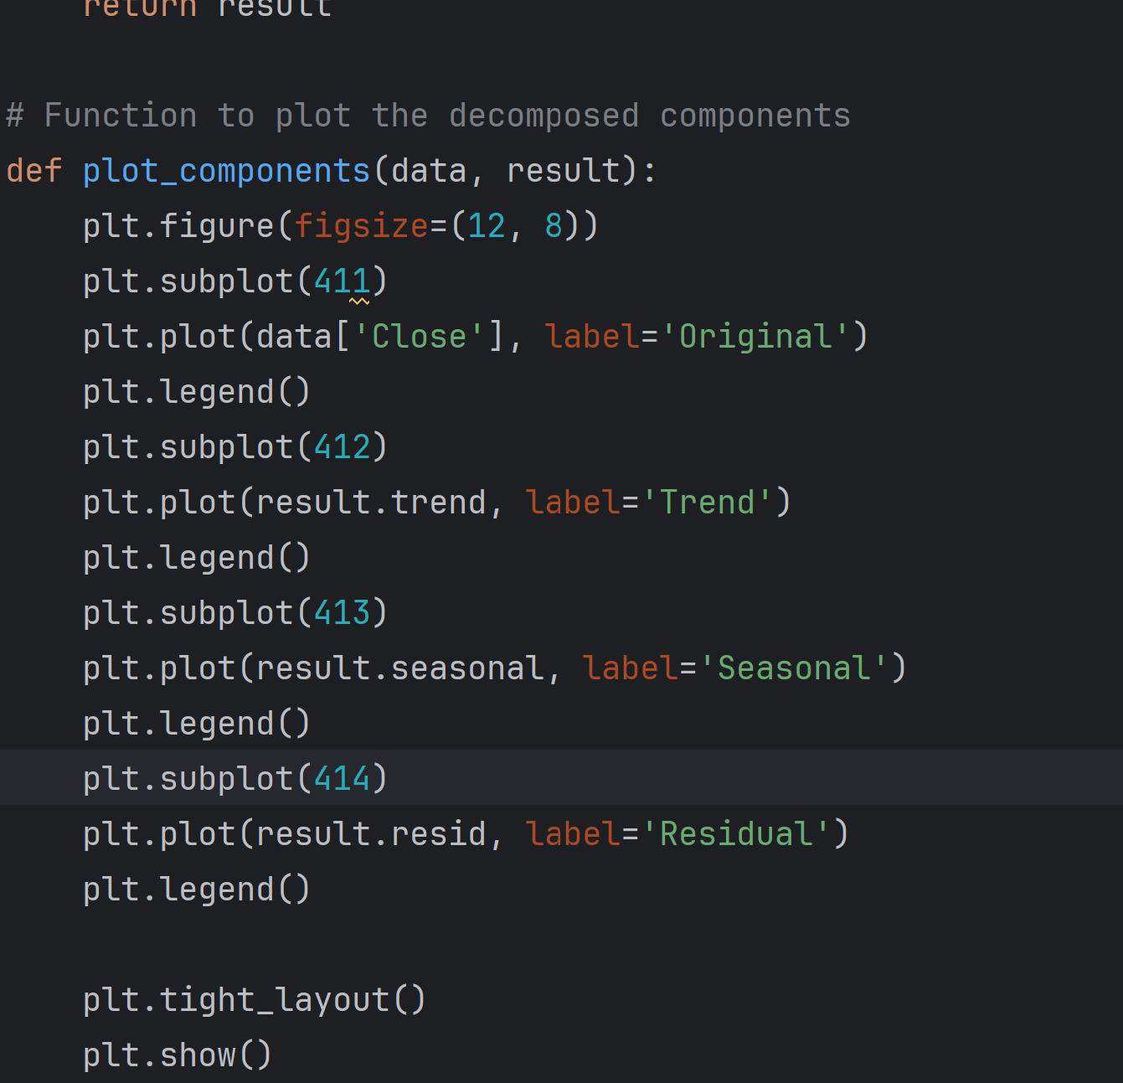

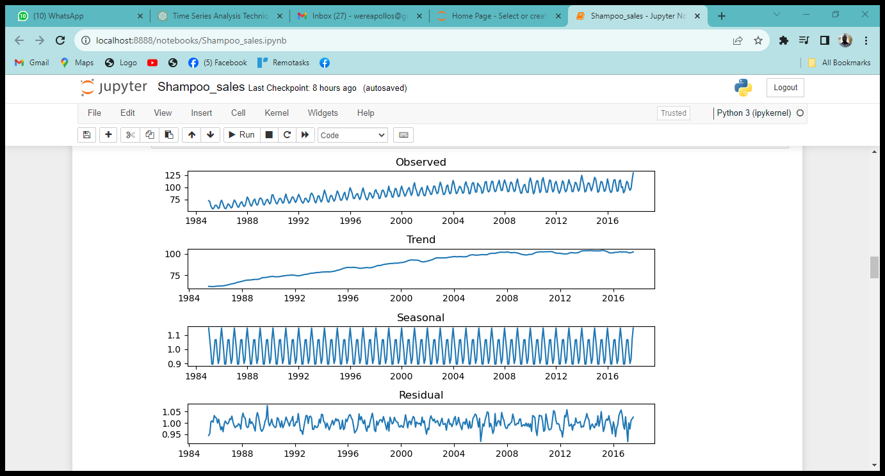

Interpreting seasonality in time series analysis involves recognizing recurring patterns or cycles that occur within the data at consistent intervals, such as daily, weekly, monthly, or yearly variations. The decompositions presented in the graph above signified predictable fluctuations that repeat over time, influenced by external factors like changes in Technology that can in turn lead to an increase or decrease in stocking price. The consistent peaks or troughs at specific intervals indicated the existence of regular patterns. The amplitude and timing of these fluctuations across different periods help us understand the impact and significance of seasonal effects on this data.

The output above displays the mean of stock market share price monthly across the years. The mean production for the month of January is higher compared to other months. We can therefore conclude that the stock price was high in the months of January across the years. Production declined in the months of April and May.

1. **Forecasting**

Forecasting stock market data is a challenging task due to its inherent complexity and the influence of various unpredictable factors. There are several methods and approaches to stock market forecasting. It's important to note that no forecasting method can guarantee accurate predictions due to the dynamic and unpredictable nature of financial markets. Additionally, past performance does not guarantee future results. Combining multiple approaches and staying informed about market conditions can enhance the robustness of your forecasting efforts. It's advisable to use forecasting models as part of a broader risk management strategy when making investment decisions. A stationarity assumption is fundamental for many time series models to ensure reliable forecasts and accurate assessments of relationships between variables over time. The ADF test statistics being lower than the critical value and the p-value falling below the significance threshold reinforce the understanding that the observed time series data is stationary. This outcome holds crucial implications for time series analysis, as it allows for the application of various forecasting models and statistical techniques that assume stationarity. It signifies that the underlying structure of the data is consistent across time, enabling more robust modeling of trends, seasonality, and relationships between variables, ultimately leading to more reliable and accurate forecasts and interpretations within the time series domain.

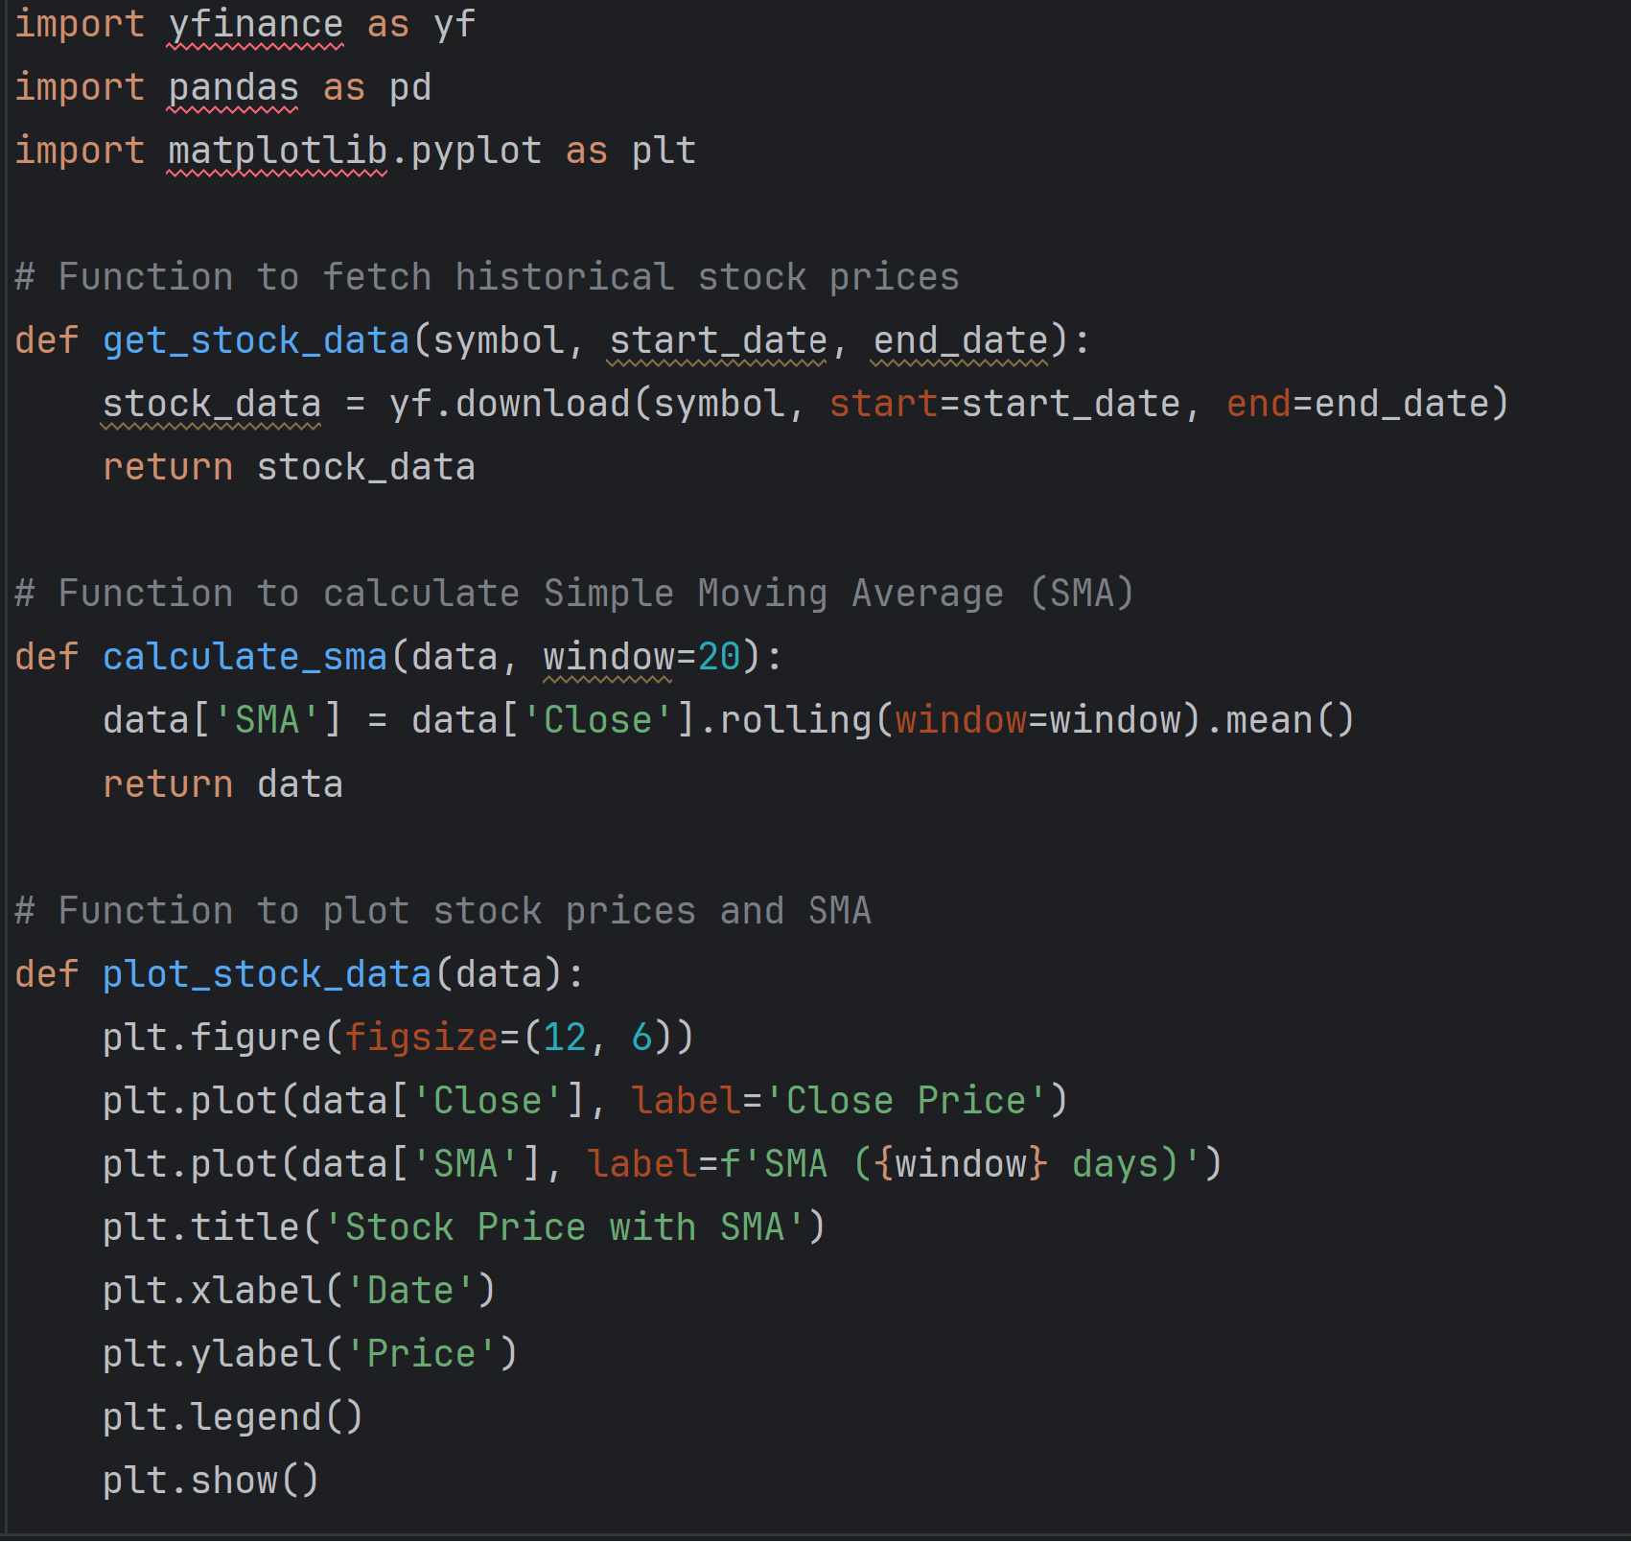 Top of Form

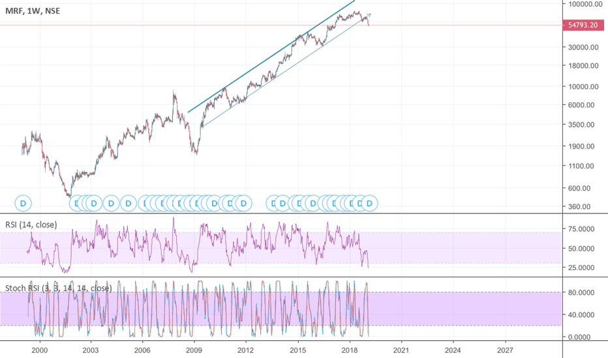

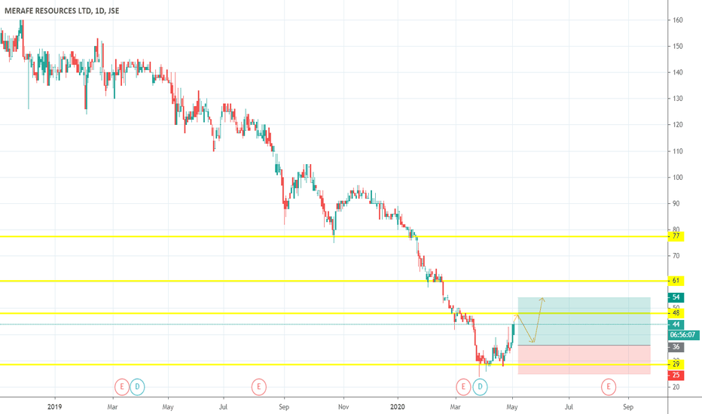

The graph above shows evidence of the absence of non-stationarity after performing ADF test statistics.

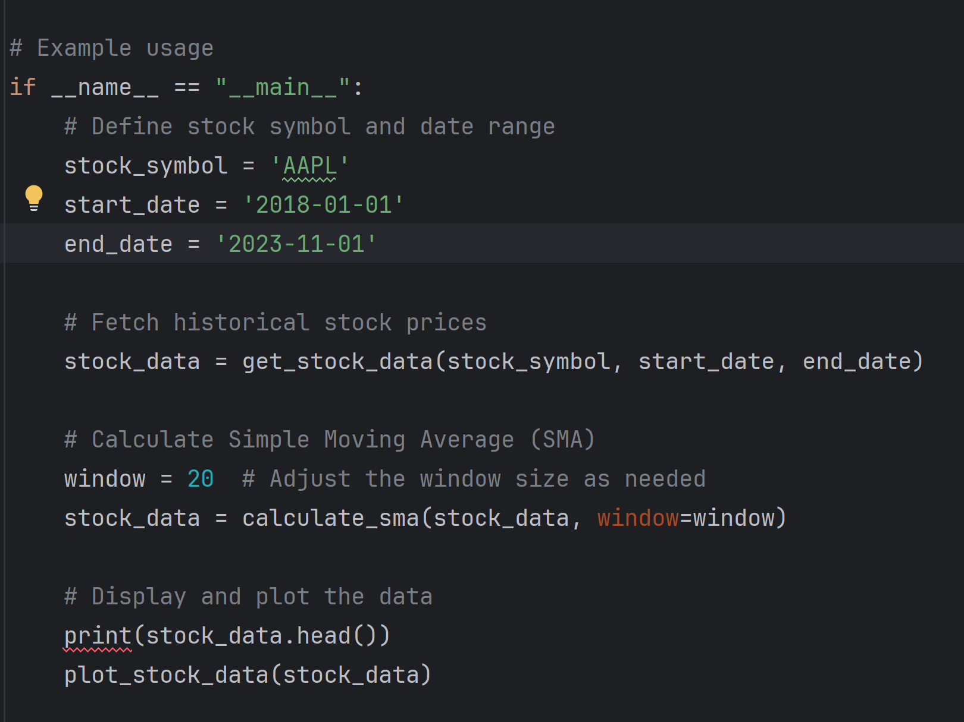

The forecast for Stock Share value price aimed to predict future values based on historical patterns and trends. In this specific case, the forecast, generated from an ARIMA model applied to the Stocking price, indicates expected changes in share value price over the projected period. The red line represents the forecasted values, while the blue line portrays the actual historical production. If the forecasted values align closely with the actual data, it suggests the model has captured the underlying patterns effectively. An upward or downward trend in the forecast indicates a potential increase or decrease in production levels, respectively. However, it's crucial to note that forecasts come with uncertainties and might not account for sudden external factors or unforeseen events that could influence production. Interpretation should consider the model's accuracy and the degree of confidence in its predictions, acknowledging that actual future production might deviate due to unanticipated circumstances